Best Advice

Term Integration Guide

Contents

- Overview
- XML message to BestAdvice
- XML message from BestAdvice
- Validation
- Error Trapping

Version 1

Overview

Bestadvice offers it subscribers access to term quote and other quotes through their website www.bestadvice.ie

An XML interface has been implemented to allow bestadvice subscribers using 3rd party tools access quotes from Bestadvice directly through an XML interface

The third party tool is responsible for validating data before being sent to the interface and for parsing and displaying the data once it is returned.

Both the message to and from the bestadvice server are in XML. To use the interface the 3rd party tool should post a field called xml with a valid XML string to

http://www.bestadvice.ie/interface3.php

XML is case sensitive and tags should be exactly as in this document

XML Message to BestAdvice

<Inputs>
<Authentication>
<Username> | Valid bestadvice username
<Password> | Corresponding password
<RequestFrom> | Valid SYSTEM name
<RequestFromCode> | Valid SYSTEM code
</Authentication>
<RequestType> | Always ‘Term’
<Life1>
<DOB> | Valid date as dd/mm/yyyy
<Sex> | ‘Male’ or ‘Female’
<Smoker> | ‘Non-Smoker’ or ‘Smoker’
<LifeCover> | Valid integer
<IllnessCover> | Valid integer
</Life1>
<Life2>
…….
</Life2>
<Plan>
<Term> | Valid integer
<Indexation> | Y or N
<MortgageInterest> | Valid integer
<Frequency> | ‘Monthly’ or ‘Annual’
<QuoteLifeOnly> | Y or N
<QuoteLifeAccelerated> | Y or N
<QuoteLifeIllness> | Y or N
<QuoteIllnessOnly> | Y or N
</Plan>
</Inputs>

XML Message from BestAdvice

<Results>
<Errors/> | Errors & Description
<Inputs/> | The inputs submitted
<Summary>
<Life1> | Life 1 summarised info
<Life2> | Life 2 summarised info
<Plan> | Plan summarised info
</Summary>
<Quotes>
<Type>
<CriticalWarning>
<InformationalWarning>
<Desc>
<Company>
<Name>
<PricePledge>
<Underwriting1>
<Underwriting2>
<SLevel>
<SConvertible>
<SMortgage>
<DLevel>
<DConvertible>
<JLevel>
<JConvertible>
<JMortgage>
</Company>
<Type>
</Quotes>
</Results>

Notes:

For single life no nodes referring to life 2 will be in the message

The Type node will be repeated for each type selected in the input XML (Life only, Life & Acc Illness, Life and SA Illness, Illness Only)

The CriticalWarning & InformationalWarning nodes will be repeated for each warning

The Company node will be repeated for each company.

Where a quote is single life the nodes SLevel, SConvertible & SMortgage will be used for two lives DLevel, DConvertible, JLevel, JConvertible & JMortgage will be used.

Each of these node has a key as follows:
key=2 means a valid quote and the text value will be the premium
key=0 means no quote and the text value is the reason why

Please find below the results of a term quote run on The BIS Platform and the corresponding XML result for a quote for one and two persons. Please note it is a business decision that the Broker will make regarding which results are displayed on their website and we ask that you liaise with the Broker in this case.

Single Life:

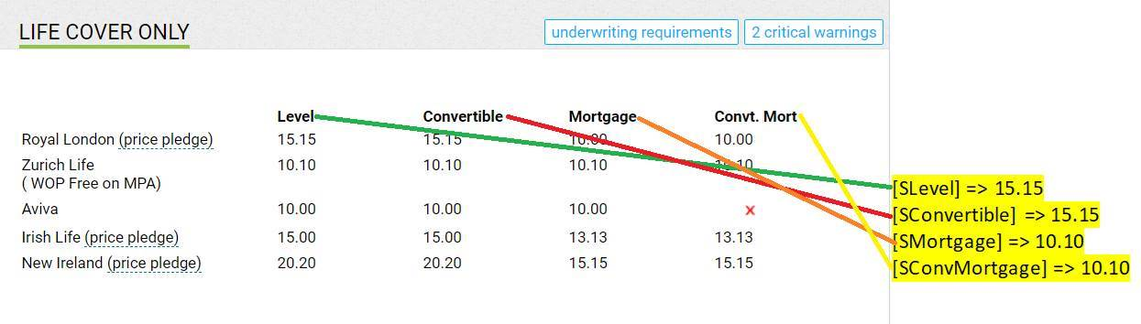
Dual and Joint Life:

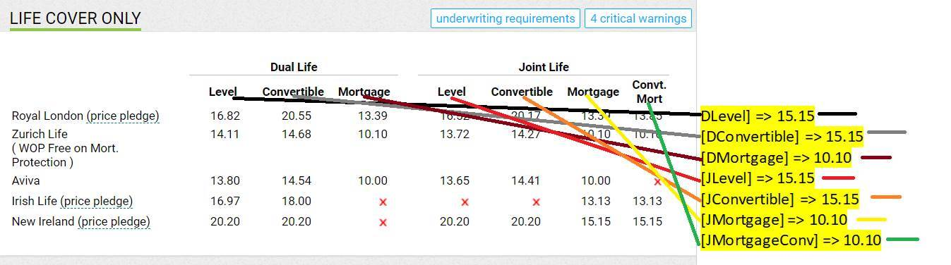

XML Message to BestAdvice

The only validation for the 3rd party tool is on the inputs side and this is mainly a date validation.

Error Trapping
Should an unexpected error occur during the quote process the result will not be an XML string. This should be allowed for in the 3rd party tool by checking for a parse error and alerting the user.

